**Expressions Day Camp**

**Counselors**

**Helping Each Child To Shine**

Hi! My name is **Emma Tierney**, and this is my third year working as a Senior Counselor for the Expressions Day Camp – Gummy Bear Group. I just graduated as a senior from Notre Dame High School in Lawrenceville NJ. During my time at Notre Dame, I was a Peer Leader, Student Ambassador and Service Leader. For the amount of 100+ hours I have dedicated to service I have received a Presidential Service Award in 2019, 2020 and 2021. Along with being heavy involved at school, I just graduated from being at my local studio, Dance Art of Yardley. I have been dancing there for the past 11 years on their Competition Team and was the senior caption of the 2021 Senior Company Team. As well as being on involved in their Yardley Youth Ballet Team which performs a Nutcracker each year. Besides dancing on their competition team, I have helped dance instructors for weekly beginner dance classes (age 4-8), including 5 years as one-on-one for a young dancer with special needs. This fall I will be attending Duquesne University in Pittsburgh PA for occupational therapy.

I am looking forward to all of the fun summer activities that are to come!

We are going to have a lot of fun this summer :)

View Emma’s welcome video: <https://youtu.be/ozXSH1pjLFY>

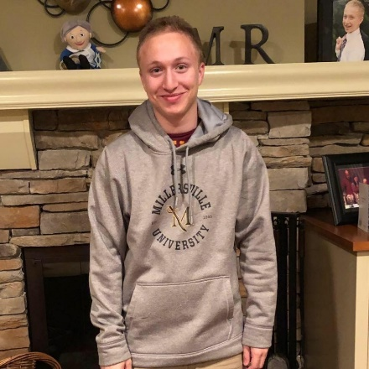Hello Expressions families, my name is **Max Levine** and I am excited to be a counselor at Expressions Day Camp for now the sixth summer in a row! I am 20 years old and will be a junior at Millersville University starting in the fall, starting with my first semester in the psychology department. Originally my major was dual early childhood and special education, which that decision was partly influenced by my experience with Expressions. With my future psychology degree, I am looking at the option of being a school psychologist, so while no longer wanting to be a teacher, working with kids is still something I desire to do. I come back to work at Expressions every year as I love the community that this camp has created so much and think it is something truly amazing. Even with the craziness that the past year and a half has been for the world, I am so glad we get to return to camp to have some sense of normalcy in our lives. Now that Summer 2021 is already upon us I am beyond excited to return to camp and help make this a summer your kids will never forget!

View Max’s welcome video: <https://youtu.be/VRiU6QAQg4g>

Hello everyone! My name is **Monica Ferguson**, and I am very excited to announce this is my first year with Camp Concepts. I am 24 years old from Upstate New York, Binghamton area, previously volunteering with Special Olympics and other organizations that work with school age children from 5-18 years old. I always knew I wanted to help people, I just never knew exactly how. Throughout college I thought I wanted to work in the medical field, but I ended up graduating with a bachelors in Community Health at SUNY Cortland. I quickly learned my true passion in life is to work with younger children. I now work at Pennsbury school district as a substitute teacher, and plan on going to Temple in the Fall to pursue a masters in Special Education. My goal this summer is to plan fun, hands on activities that challenge campers to grow in ways they never thought imaginable. I am counting down the days until I meet everyone!

View Monica’s welcome video: <https://youtu.be/fqGzl0_hlsQ>

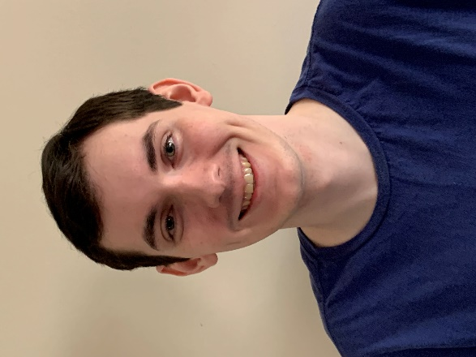My name is **Zachary Lucas**, and I am very excited to be starting my 4th year as a counselor at Expressions Day Camp. I just completed my Associates Degree in Chemistry at Bucks County Community College. I will be attending Rider University in the Fall where I will be a dual major of Secondary Education and Chemistry. I bring with me three years’ experience as a CIT from KidsCamp of Pennsbury. I earned my 3rd degree black belt in karate from Action Karate Newtown where I have been a student for the last 11 years. In my free time, I like spending time with my friends, watching and playing sports and playing video games. I’m looking forward to another great year with Expressions Day Camp.

View Zach’s welcome video: <https://youtu.be/zD5cWLrkDcc>